RECORD OF TOOL BOX TALK
Workplace: |  |  | Date:
Name of supervisor or presenter: |  |  | Time:
Name
Topic discussed, Selecting, and wearing a face mask – Please Demonstrate
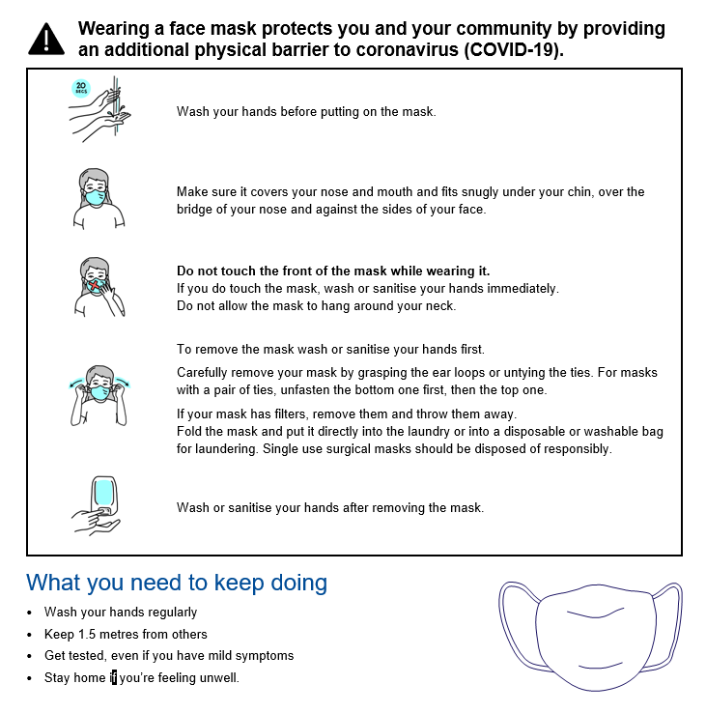

RECORD OF TOOL BOX TALK
Workplace: |  |  | Date:
Name of supervisor or presenter: |  |  | Time:
TOPIC DISCUSSED: Selecting and wearing a face mask
Persons present
Name | Signature | Name | Signature
Comments/Feedback

