Date: Time:

Topic: Dealing with Slippery Tiles
Management are monitoring the possible slip hazards presented by the floor tiles in many areas of the new dealership.
The following information is presented to ensure your workplace remains safe and any slip hazards are controlled.

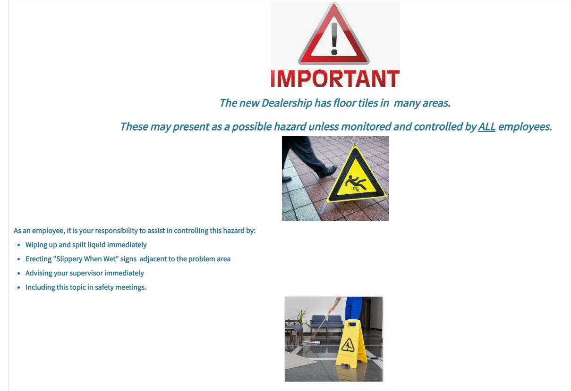

Facilitator: Signature:

Persons Attending
Name | Signature
Persons Attending…cont.

