RECORD OF TOOL BOX TALK
Workplace: | Date:
Name of supervisor or presenter: | Time:
Topics discussed: How to use the spill kit
How to use the spill kit
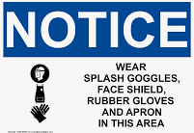
Step 1: Protect yourself!
Open the spill kit and put on the Personal Protective Equipment (PPE) within including gloves, googles, and apron.

Step 2: Recognise and evaluate the spill.

Step 3: Respond- Stop the discharge at the source

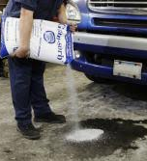
Small spills:
Place absorbent pads or granular absorbent on the fluid or anywhere needed and allow
them to soak up the fluid.

Large spills:
Protect drains and other sensitive areas by placing booms or snakes around them, and
then place at the forward edge of the spill. Then place absorbent pads or granular absorbent on the spilled fluid.

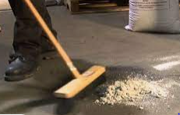
Step 4: Clean up
Once absorbent materials are saturated and the spill has been complete absorbed, dispose of
them in the garbage bags in your spill kit. Use a broom and dustpan to collect granular
absorbent for disposal. Disposal of this waste may be governed by local
regulations depending on the chemical spilled and amount.
Contact your local council for advice.

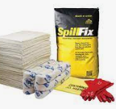
Step 5: Prepare for another spill
Replace the consumable equipment (PPE, absorbent materials, garbage bags) in the spill kit so you are prepared in the future. Replacements can be purchased from your local safety shop.

