RECORD OF TOOL BOX TALK
Workplace: | Date:
Name of supervisor or presenter: | Time:
Topics discussed: Evacuation Procedures Refresh

All emergencies will require a different response; Some emergencies you may encounter at work Include:
- A medical emergency – heart, asthma attacks etc
- Armed hold up or intrusion
- Suspicious Package
- Cyclone – extreme weather

The response for these emergencies is available on the Emergency Procedure wall chart in your work area. Please familiarise yourself with these procedures.
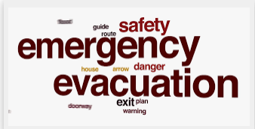
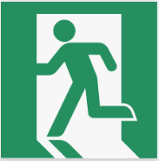

GENERAL EVACUATION PROCEDURES FOR FIRES Etc.

STAGE 1: - Removal of people from the immediate Danger Area
Occupants and staff in the immediate danger area are to assemble a safe distance away from the fire and smoke. When the area has been evacuated all doors and windows should be closed to contain fire.
STAGE 2: - Removal to a Safe Area
If the severity of the smoke or fire warrants further evacuation, occupants should be moved through fire/smoke doors to a safe area.
STAGE 3: - Complete Evacuation of Entire Complex
Should the emergency necessitate evacuation of the whole building, the Manager or the Fire Service will direct occupants from the safe place to the ASSEMBLY AREA.
STAGE 4: - Roll Call.
To be conducted as soon as possible and to ensure all persons are accounted for. Report all missing persons to Emergency Services personnel

