RECORD OF TOOL BOX TALK
Workplace: | Date:
Name of supervisor or presenter: | Time:
Topics discussed: CYCLONE PROCEDURE

PROCEDURES FOR CYCLONES

BEFORE AND DURING THE CYCLONE
- Try to remain calm
- Move away from windows and outside walls
- Keep away from furniture and fittings that may fall
- Follow the advice from the cyclone warnings
- If possible, take cover under a desk or in a toilet
- Sit down, protect your face and head
- Don’t use the phone except for serious injury
- Don’t use vehicles except for serious injury

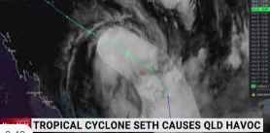

AFTER THE CYCLONE
- Don't go outside until officially advised by the Chief Warden it is safe.
- Listen to local radio for official warnings and advice.
- If you have to evacuate, or did so earlier, don't return until advised. ...
- Beware of damaged power lines, bridges, buildings, trees, and don't enter floodwaters.

